# AINT 253 Design Challenge

## Door Project

### Inntel Idea

The task is to design a door that can be interacted with within Unity. This allows a vast amount of options to use such as the style of door, how the interaction is carried out and the accompanying audio.

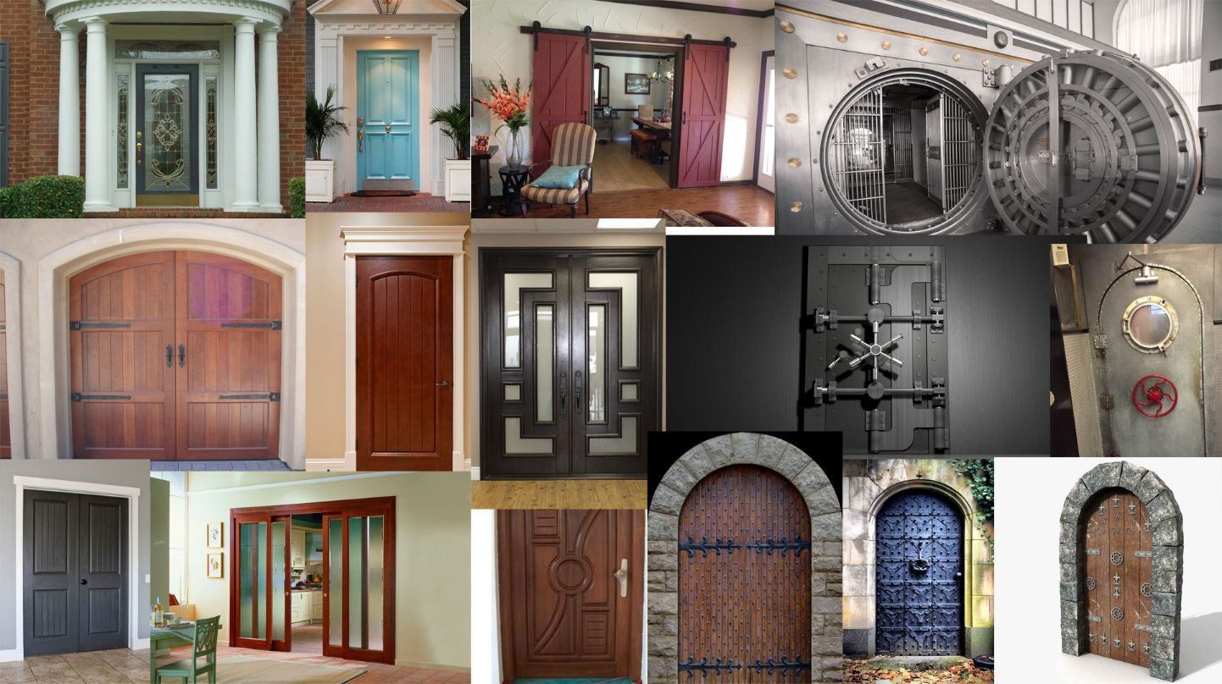For this design challenge, I want to design an iconic door that is very distinctive meaning the style and interactions need to be specific and clear for the client. To help me with the decision of the doors I have created a basic mood board with a wide verity of door below.

Exploring the different types of doors that are available the most iconic ones have a specific job such as the vault safe or the church entrance but creating a simple door would possibly pay off better with allowing more time to focus on the interaction with the door in Unity rather than making it look pretty.

Texturing is a major part of creating a realistic model because if the textures do not match with the door or if the model has some awkward geometry the texturing can warp and ruin the outcome. From many of the images within the mood board, the texture of the doors is primarily wood with some exceptions such as the safe and submarine door. In modelling it’s important to designate a reasonable amount to time to texturing since there is the option to download relevant textures some the internet but the result can be unexpected if the model isn’t correct. This means that there is the option to create my own textures within programs and Unwrap UVWs within 3ds max and assign the textures to the locations that are needed specifically.

### Chosen Idea

The type of door I have chosen is a simple sliding door, designed to go into a living room or kitchen which splits an open room into 2 separate rooms. 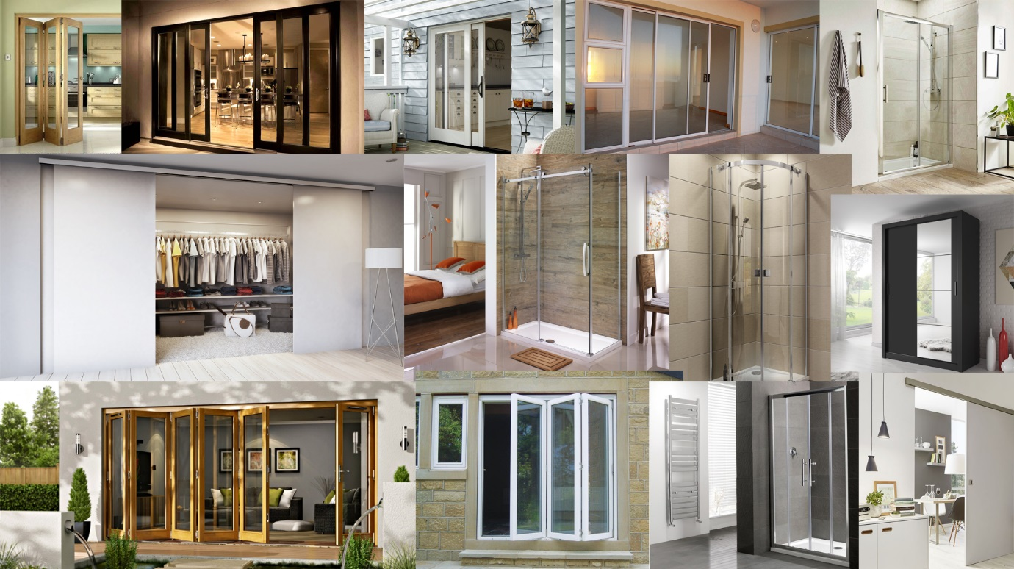

From the mood board above there is a clear theme across all the images and that is simplicity with little detail but still providing a high-quality outcome. Within the board there are a few types of sliding doors such as the simple single sliding door to a 2-curved sliding shower door. For these doors, there are very few hinges to create any sort of creaking sound effect meaning that the for the sound design, I will need to find a rolling sound with a latch click to provide audio feedback for the user. With these doors the is little texturing to do but trying to get a realistic glass effect will be challenging.